USDA Plans Projects to Help Farmers with Erosion, Carbon Dioxide
By: Anthony Humes
Posted: Wed 6:29 PM, Jul 29, 2015
http://www.kfyrtv.com/home/headlines/USDA-Plans-Projects-to-Help-Farmers-with-Erosion-Carbon-Dioxide-319641181.html
-+
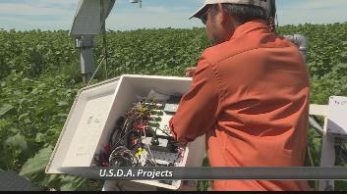
The wind can have an effect on a much smaller scale, and that's something the Department of Agriculture is looking at. It's actually working on two projects designed to help farmers.
One will monitor wind erosion and the other looks at carbon dioxide.
In 2012, the Long-Term Agroecosystem Research Network was created so experiments could be done in different climates and weather situations. One of the projects being worked on at the research facility in Mandan is to lower greenhouse gas emissions.
"We can calculate the exchange of water vapor and carbon dioxide between the ecosystem and the atmosphere," said Dr. Nick Saliendra, U.S.D.A.
The experiment tests how well sunflowers reduce net greenhouse gas emissions.
Saliendra said, "Well, it's important because of ongoing climate change you can measure how much carbon dioxide is being absorbed by ecosystem"
Anther program aims to help farmers minimize wind erosion to their soil.
"It's important because we don't want to go back to a dustbowl era we want these eco-systems to be productive, we want sustainable crop systems, agricultural systems long term and we want to improve soil health," Dr. David Toledo, U.S.D.A.
A number of sensors on the ground detect how much soil is being blown around when sunflowers are the crop of choice.

